
Instructions for Filling out Online Forms

- Click the form you would like to fill out.

- Type in your name.

- The red arrow on the left hand side of the screen will guide you to the required fields that you must fill out to submit the form.

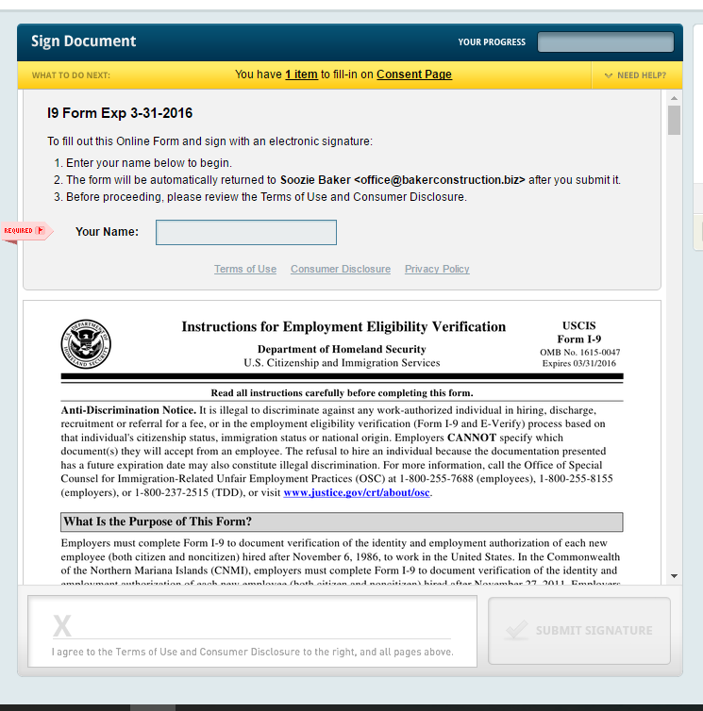

- Please read through and fill out each box that applies to you even if it is not required.

- When you need to sign the document, click the “signature field”.

- Draw your signature using the mouse.
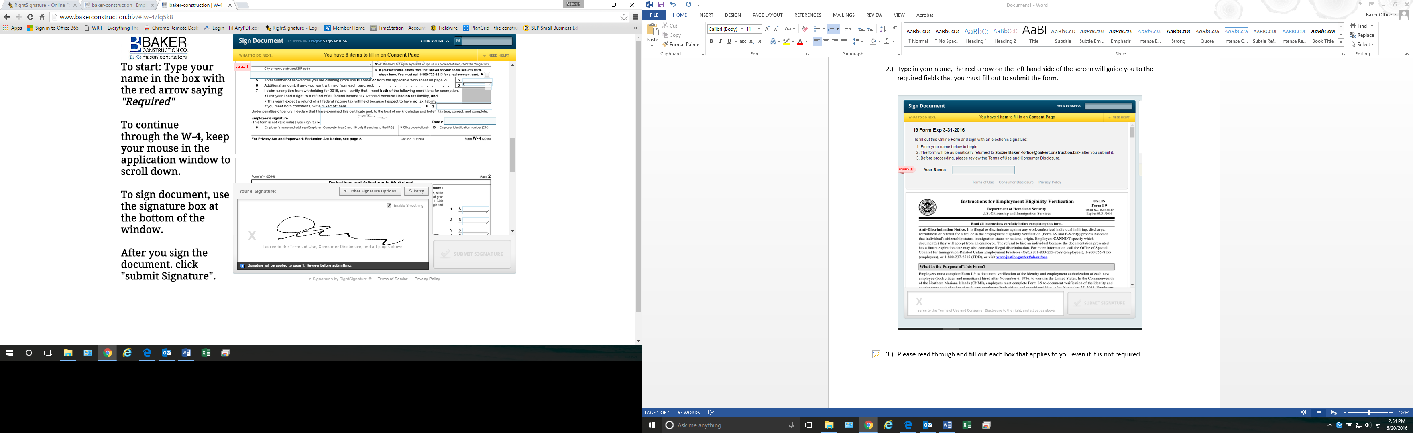

- If all the required fields have been filled out, click “Submit Signature”. If not, follow the red arrow to see which fields you missed.

- If you have any questions, please call the office (810) 231-6913.

